

**Symbiosis Institute of Technology**

**Faculty of Engineering**

**CSE- Academic Year 2024-25**

**Data Structures – Lab Batch 2023-27**

|  |  |
| --- | --- |
|  | **Lab Assignment No:- 2** |
|  |  |
| **Name of Student** | Laxmi kumari sah |
| **PRN No.** | 23070122125 |
| **Batch** | 2023-27 |
| **Class** | CS-B1 |
| **Academic Year & Semester** | 2023-24 & Semester 3 |
| **Date of Performance** | 30/07/2024 |
|  |  |
| **Title of Assignment:** | A. Implement following sorting techniques and find the time complexity:: i. Bubble ii. Selection iii. Insertion |
| **Theory Questions:** | 1. Prepare table for following 10 different sorting algorithms for their best case, average case and worst case time complexities. 2. Solve examples of bubble sort, insertion sort and selection sort. Show all passes. 3. Write real world applications of bubble sort, insertion sort and selection sort. 4. How we can optimize bubble sort. |

1.

2.

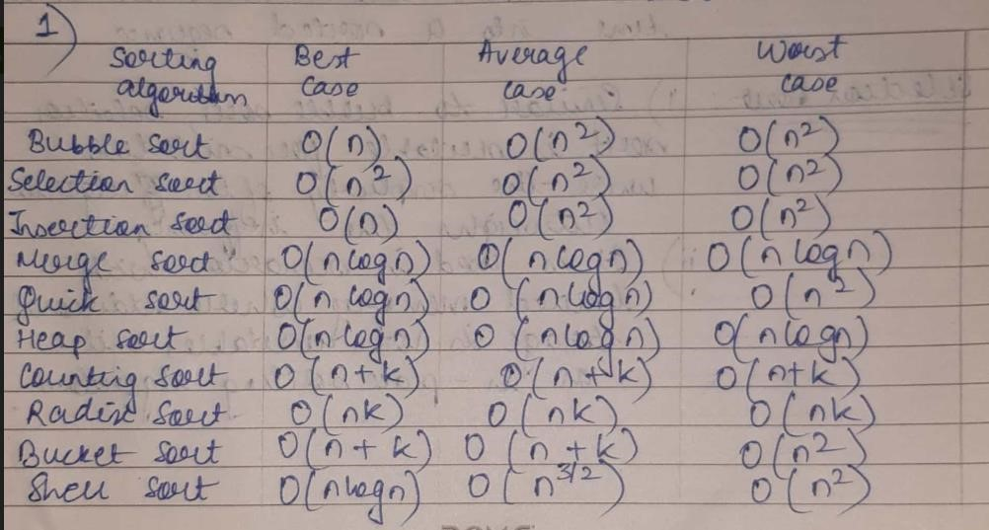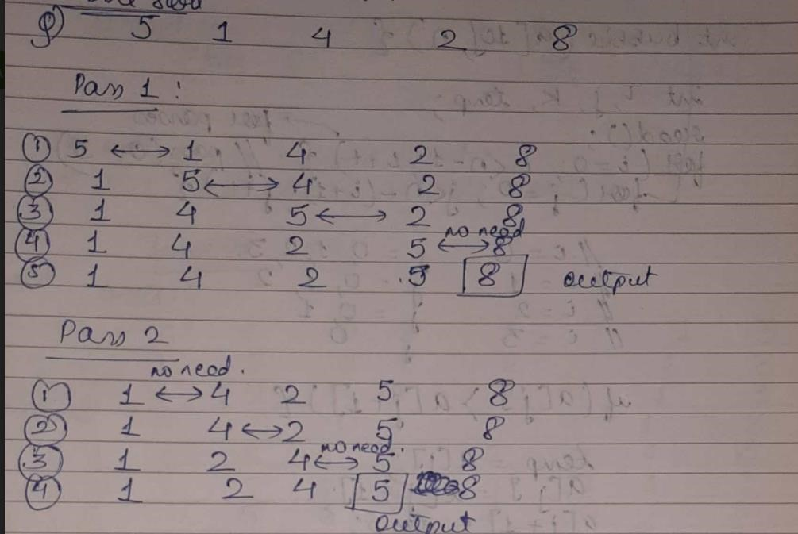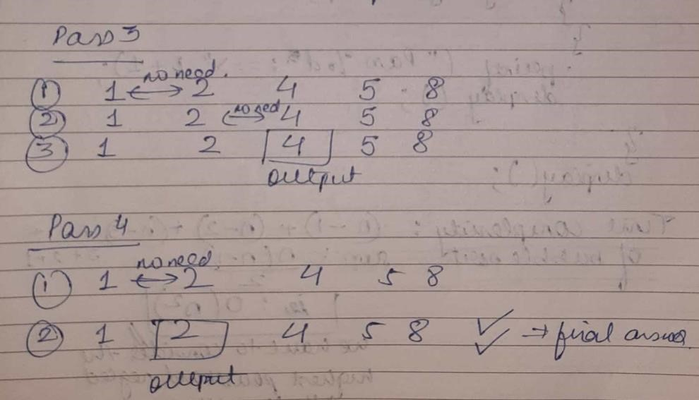

|  |  |
| --- | --- |
|  | Insertion sort:        3. |

|  |  |
| --- | --- |
|  | 4. |

|  |  |
| --- | --- |
| **Source**  **Code/Algorithm/Flow Chart:** |  |
| **Output Screenshots** |  |

|  |  |
| --- | --- |
| **Practice questions** | 1. Implement Optimized bubble sort 2. o/p screenshot |
| **Conclusion** | Thus we have studied different sorting algorithms and their time complexities. |